**2. Problem Statement**

**Implement the concept given in below blog link and share the complete steps along with**

**screenshots.**

[**https://acadgild.com/blog/loading-data-into-hbase-using-pig-scripts/**](https://acadgild.com/blog/loading-data-into-hbase-using-pig-scripts/)

**Start all the services for the hdfs terminal.**

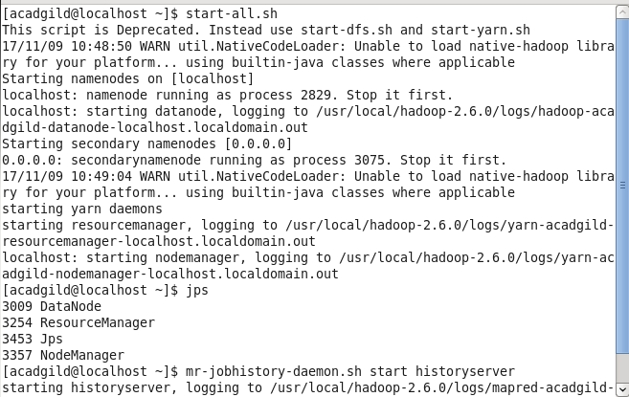

**Will see the file and directory present in hdfs mode.**

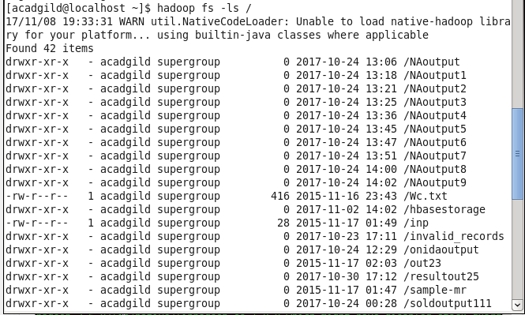

**We will be copying the data set in to HDFS which will be further loaded into HBase.**

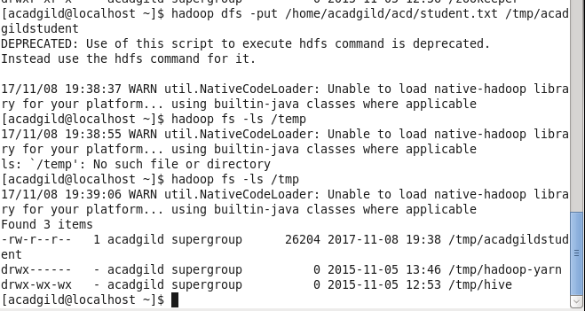

**We will be including few jar files of HBase to the Pig classpath.**

**PIG_CLASSPATH=/home/hadoop/HADOOP/hbase-0.98.4-hadoop2/lib/hbase-server-0.98.4-hadoop2:/home/hadoop/HADOOP/hbase-0.98.4-hadoop2/lib/hbase-*.jar;**

**We will now start HBase shell and create a table**

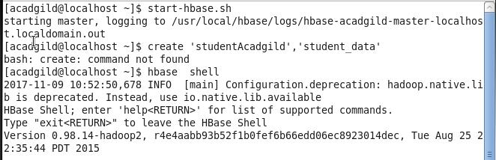

**.We only need this table as skeleton so PIG can Store data inside this by referring the table name.**

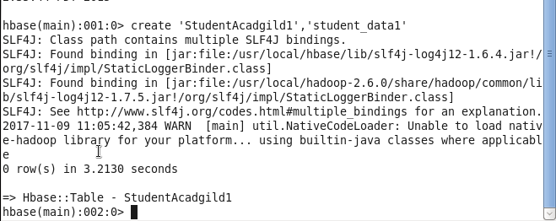

**We can come out from HBase by typing exit and switch to PIG grunt shell.**

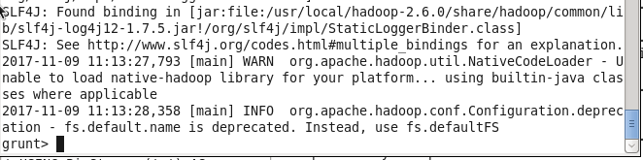

**Once we are inside PIG mode we can load data from HDFS to Alias relation.**



**Now we can transfer the data inside HBase by STORE command.**

**We need to ensure that we give the correct name for table name created inside HBase. Also the parameters should be kept in mind to avoid mistake.**

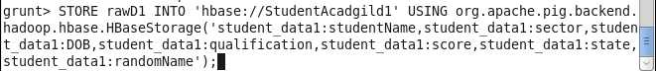

**Once the success message comes as shown below , it is confirmed our data is loaded inside HBase.**

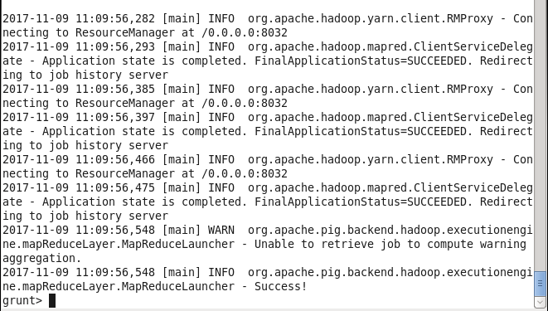

**The result can be displayed through scan command followed by table name inside quotes( ‘ ‘ ).**



